

DHAN SCMS

Project Documentation Submitted to the Faculty of the
School of Computing and Information Technologies

Asia Pacific College

In Partial Fulfillment of the Requirements for
Introduction to Systems and Design for CS/IT
M/S NTSDEV

By
Daniel Louis Balubar | Carl P. Agot
Hans Edwin Y. Maybituin | Noel D. Catabona

2024

Table of Contents
Table of Contents 1
Executive Summary 2
List of Figures 3
Data Flow Diagram 4
Activity Diagram with Swimlanes 4
List of Tables 5
I. Introduction 6
1.1 Project Context 7
1.2 Statement of the Problem 7
1.3 Objectives 9
1.4 Significance of the Project 10
1.5 Scope and Limitations 12
II. Review of Related Literature / Systems 13
2.2.3 Implementation of Barcode on Warehouse Management Systems for efficiency 18
2.2.4 Optimizing SCM with Python 19
2.2.5 Role of AI in Inventory Management 20
III. Current Systems 23
3.1 Current System 24
3.2Technical Background 24
3.3 List of Processes 24
3.4 Gap Analysis 26
3.5 SWOT ANALYSIS 26
3.6 FISH BONE DIAGRAM 26
IV. Proposed Solution 27
4.2 Lean Canvas 27
4.3 Product Vision 30
4.4 Technology Specifications 31
4.5 Feasibility 33
V. Requirements Analysis 34
5.1 Product Backlog / User Stories 34
5.2 Use Case Diagram 35
5.3 Data Flow Diagram 36
5.4 Fully Dressed Use Case 39
5.5 Test Cases 46
5.6 Activity Diagram with Swimlanes 55
5.8 User Classes and Characteristics 60
5.9 Prototype 61
5.10 Release Plan 69
References 69
Appendices 71
Appendix A: Project Vision 71
Appendix B: Schedule/Release Plan 72
Appendix C: Product Roadmap 73
Appendix E: Teams Meetings 74
Appendix F: Data Dictionary 77

Executive Summary

The System that we will use in Supply Chain Management Systems or (SCMS) will be a web-based solution to meet the needs of MEGAION, this system aims to automate and innovate inventory management by implementing scannable barcodes with location tracker for every machine. The system has a real-time status dashboard with separate tabs for inventory and location tracker.

The importance of maintaining accurate records makes the supply chain management system essential. Our team is developing the DHAN Supply Chain Management System (SCMS) to address these challenges, providing a solution for MEGAION to efficiently store.

List of Figures

Figure 1 Fishbone Diagram ……………………………………..…………………………...……… 15
Figure 2 Use Case Diagram ...…………………………………………………………………….… 23
Figure 3 Login Page ...…………………………………………………………………………........ 25
Figure 4 Landing Page ...………………………………………………………………………….... 26
Figure 5 Inventory Tab ...……………………………………………………………………….…... 27
Figure 6 Reports Tab ...………………………………………………………………….………...... 28
Figure 7 Shipment Status ...……………………………………………………………………...… 29
Figure 8 AI Module ...……………………………………………………………….………......…... 30
Figure 9 AI Module ...……………………………………………………………………….......…... 31
Figure 10 Release Plan ...…………………………………………………………………...….…... 36

Data Flow Diagram

Figure 11 Level 0 of Data Flow Diagram....................................................................................29
Figure 12 Level 1 Megaion Supply Chain Management System................................................30
Figure 13 Level 2 Process 1.0 Create Purchase Order..............................................................31
Figure 14 Level 2 Process 2.0 Manage Inventory......................................................................32
Figure 15 Level 2 Process 3.0 Tracking of Procuct....................................................................33
Figure 16 Level 2 Process 4.0 Supply Updates.........................................................................34
Figure 17 Level 2 Process 5.0 Access Dashboard.....................................................................35
Figure 18 Level 2 Process 6.0 Using AI ASSISTANCE.............................................................36

Activity Diagram with Swimlanes

Figure 19 System Process.........................................................................................................52
Figure 20 Dashboard System....................................................................................................53
Figure 21 Inventory Mangement................................................................................................54
Figure 22 Process Equipment...................................................................................................55
Figure 23 Barcode Operations...................................................................................................56
Figure 24 AI Assistance.............................................................................................................57
Figure 25 Tracking of Product....................................................................................................58
Figure 26 Purchase Order.........................................................................................................59
Figure 27 View Product Shipment.............................................................................................60
Figure 28 View Retrieval of Product..........................................................................................61
Figure 29 View Purchase Order................................................................................................62
Figure 30 View Order Report.....................................................................................................63

List of Tables

Table I List of Processes ………………………………………………………………………… 12-14
Table II SWOT Analysis ………………………………………………………………….……… 14
Table III Product Vision …………………………………………………………………..……… 18
Table IV Category and Specifications ……………………………………………..…………… 19
Table V Product Backlog ………………………………………………………………………… 21-22
Table VI User Classes …………………………………………………………………...……… 24
Table VII Road Map ……………………………………………………………….....………….. 37

Introduction

In the contemporary medical industry, reliable supply chain management is critical for ensuring the timely availability of essential medical equipment (MRI, Electrolytes analyzer, hospital beds, non-consumables). The complexity of handling various medical equipment, the need for fast and efficient tagging, and the imperative to maintain accurate records necessitate a comprehensive supply chain management system. Recognizing these challenges, our team will develop the DHAN Supply Chain Management System (SCMS), a solution specifically designed for MEGAION, involved in storing, distributing, and delivering medical equipment.

Project Context

For businesses that distribute and store medical equipment, such as MEGAION in Paranaque City, an efficient supply chain management system is essential for success. The nature of medical supplies demands precise inventory tracking, procurement efficiency, logistics coordination, and strict adherence to regulatory guidelines. Traditional supply chain management systems, often reliant on manual processes, are susceptible to human errors and delays. These shortcomings can jeopardize the availability of vital equipment, highlighting the urgent need for a more advanced, reliable, and user-friendly supply chain management system.

Statement of the Problem

Our client, a medical equipment distributor, is struggling with their inventory management due to a large manual process. This makes it hard to maintain accurate and up-to-date records. The complexity of their operations and strict regulatory requirements further complicates the situation.
The specific problems they are facing includes:
- Manual process of tracking stock levels for delivery or demonstration of machines, leading to potential delays. MEGAION recognizes the need for a reliable inventory management system to mitigate these risks. According to Edson Maybituin, the Inventory Manager, he struggles to keep up with the current system and the extensive manual process, citing increased error susceptibility.

- There are instances when the products are understocked, leading to supply disruptions. According to Edson Maybituin, the inventory manager, he also stated that there is a problem with an advance purchase order with currently zero (0) stock for machine equipment.

- Outdated and inefficient process of machine retrieval after demonstration. According to Edson Maybituin, the Inventory Manager, machines used for demonstrations are not being retrieved. There are times when these machines are not logged into the system, resulting in missing stock.

Objectives

To automate and streamline the inventory management system of the medical equipment distributor using barcodes, ensuring accurate tracking, real-time status updates, and integrate supply chain management system.
To resolve these challenges, the client aims to automate their inventory system, and here are the specific objectives:
- To reduce the delay in checking stock levels for items that are for delivery or demonstration by 95%.
- To optimize processes and ensure seamless coordination among stakeholders in the supply chain of MEGAION, particularly when sourcing hospital equipment from various suppliers.
- To streamline the process for retrieving and logging demonstration machines to mitigate instances of missing stock.

Significance of the Project

Fixing the client’s problem is the main goal of creating this project. Adapting to modern technologies and incorporating them into the client’s business will enhance the current system that they are using. Furthermore, creating this system will negate any employees’ hindrances in doing their work. The project will benefit the following:

- Business Owner/s:
This project will benefit the business owner/s because they will have an improved system that will assist their challenges in encoding items, profiling data, and checking their own inventory. Furthermore, the client could utilize various project features that will help manage their business.

- Service Employees:
This project will benefit the service employees by providing them with a way to manage what goes in and out of their inventory, what available stocks they currently have, and the items being prepared to sell. This will help minimize errors for any employees using the system.

- Developers
As for the developers, this project will benefit them because it gives them broader knowledge on how to tackle a problem and think of a technological solution that comes along with it. The developers would have a clear understanding of how to plan the project, build it, and implement it to solve the problem they’re facing.

Sustainable Development Goals:

SDG No.9: Industry, Innovation and Infrastructure
- To promote innovation in modern technologies, facilitating local and international trade in the medical industry.

Scope and Limitations

The supply chain management system will automate the inventory management, procurement, and logistics coordination. The focus of this project will be on items that go in and out of the inventory, procurement efficiency, and logistics. The focus will be implementing important features such as building user dashboard and modules. Furthermore, the creation, selection, and deletion of products will also be part of its features. Moreover, the system will also cover reporting that will provide a centralized dashboard with real-time data and customizable reports. The barcode scanning functionality of the system will automatically demonstrate if a product is for delivery or for demonstration. It will also be automatically added to the inventory dashboard of the system. If the product is for demonstration, there will be a notification system that will notify the client in retrieving the machines after demonstration. In procurement management, a feature would be added in placing orders for products and making invoices. A real-time location tracker will also be added to the system. This will help in tracking the location of machine equipment that is for demonstration. Lastly, there will be an AI assistant that will be used in demand forecasting, inventory needs, and potential supply chain disruptions.

This project will only focus on inventory management, procurement, and logistics. Other matters such as company expenditures and sales will not be involved in the project. Lastly, the project will only limit its coverage to the current developers and clients that will be able to access the product.

Review of Related Literature / Systems

2.1 Related Applications

Anaplan
A software called Anaplan is well-known for its sophisticated analytics features, which include machine learning and predictive analytics to improve forecast accuracy. The software also facilitates scenario planning, which enables companies to assess the possible effects of different situations. Because of Anaplan's platform's great degree of customization, companies may easily adapt their forecasting models to meet their unique requirements. Because of this versatility, businesses can include specific workflows, business rules, and scenarios into their forecasting procedures. High data volumes and complicated models can be handled by Anaplan without affecting performance. Large organizations or companies with intricate supply chains that need to handle and analyze big datasets to produce precise forecasts must have this scalability. [1]

Magaya
For handling the entire logistics process—from quotation to billing—Magaya is the finest option. With Magaya, users may quickly and accurately provide quotes for clients based on current pricing, which include carrier rates, surcharges, and other costs. This feature makes quoting easier and aids in more effectively securing business. Users can also handle all shipment kinds on a single platform, including air, sea, and ground. In addition to creating shipments, combining cargo, and handling the associated paperwork, this also entails giving a comprehensive progress report for each shipment. The software comes with features for managing compliance with customs laws, such as creating the required paperwork and electronically submitting it to the appropriate customs authorities. [1]

Netstock
Netstock's ability to foresee demand is one of its advantages. It helps businesses manage ideal stock levels and lower the risk of stockouts or excess inventory by using sophisticated algorithms and past sales data to forecast future inventory demands. Advanced analytics tools in the program offer information on inventory performance. For proactive inventory control, it can draw attention to problems including overstock, understock, and product obsolescence. Multiple departments and outside partners are frequently involved in effective SCM. All parties involved in inventory management may easily communicate and coordinate thanks to the collaboration options offered by Netstock.[1]

Ordoro
Ordoro is an online platform that helps you manage all aspects of your shipping. An online tool called Ordoro assists you in handling every facet of your shipment. With this platform, you can manage returns from one or more locations, assess inventory, print postage, and give consumers tracking information. Ordoro is compatible with a number of e-commerce sites and marketplaces, such as Shopify, Etsy, Amazon, and eBay. From a single dashboard, you'll be able to simply process shipping labels for each order and keep track of them all [2].

Cin7
Cin7 is a cloud-based inventory management tool made to assist companies incontrolling their stock, orders, and sales via a variety of distribution methods. It is a complete solution for companies trying to optimize their operations since it incorporates multiple features like order management, inventory control, point of sale (POS), and warehouse management [3].

Odoo
Odoo is an all-in-one program for managing businesses. Numerous applications are available for it, including inventory management, HR administration, sales and purchase management, accounting, and much more. It is simple to use for both administrators and end users thanks to its intuitive UI. Apart from the typical functionalities of accounting software, Odoo comes with a range of pre-built business processes that can be tailored to your specific requirements or utilized exactly as is [4].

2.2 Related Literature

2.2.1 Marketing Adaptation to Modern Technologies
Marketers must stay ahead of the technological curve due to the applications and solutions that follow technological advancements, which have never-before-seen consequences and results. For instance, it's critical to determine how new technology will probably affect business strategy as well as consumer (and customer) behaviors. In addition, new developments in data storage, analytics, and technology present marketing professionals with chances to generate, share, collect, and provide worth for their clientele [5].

2.2.2 Implementation of Automated Inventory System to Medium-sized Enterprises
The advantages and disadvantages of setting up an automated inventory management system for SMEs are thoroughly discussed in the case study of the business. The business was able to reduce costs, simplify its inventory management processes, and improve client support after implementing the new technology. The case study demonstrates how important it is for small and medium-sized businesses to consider the advantages and disadvantages of utilizing an automated mechanism for managing inventories. Prior to starting such projects, SMEs ought to assess the technical complexity of the procedure for implementation, the requirement for employee training, and the possible return on investment [6].

2.2.3 Implementation of Barcode on Warehouse Management Systems for efficiency
Barcode implementation in warehouses has many benefits, including the ability to reduce errors in receiving goods and speed up this process; can automatically determine the location of storage; can minimize errors in storing goods at the storage area; can reduce errors in location and goods picked by the picker; it can help identify excess or insufficient inventory; it can determine the suitability and quality of the goods to be shipped; it reduces human error in checking goods; it uses less paper; and it speeds up the process of issuing manifests for shipping [7].

2.2.4 Optimizing SCM with Python

Pandas and scikit-learn, two of Python's data analysis tools, enable analysts to glean insights from supply chain data. This facilitates decision-making based on evidence rather than intuition. Python helps analysts more correctly forecast demand, estimate delivery schedules, and predict inventory levels. Furthermore, reinforcement learning techniques in Python's machine learning capabilities can enhance vehicle routing, warehouse storage sites, predictive maintenance, and other features. Businesses can get information on inventory levels, transportation costs, demand forecasting, and other topics by utilizing data and analytics. Python is a useful tool for supply chain optimization and analytics. Algorithms utilizing machine learning, for instance, can identify trends and forecast ideal stock levels. [8]

2.2.5 Role of AI in Inventory Management

AI technologies hold the potential to completely transform the way firms manage their inventories by optimizing workflows, reducing expenses, and improving overall effectiveness. It's anticipated that this shift would affect small manufacturers and distributors in addition to big businesses.[9].

Artificial intelligence (AI) systems can forecast future demand by analyzing past sales data. This helps firms avoid stockouts or overstocking by helping them maintain ideal inventory levels. For improved predicting accuracy, AI can also take seasonal patterns, market movements, and other variables into account. AI, for example, can spot a trend in which demand for a given product rises during important athletic events. Then, by keeping an eye on event calendars and historical sales trends, it can forecast these increases in demand. To seize these chances, the business can modify its marketing plans and inventory levels [9].

2.2.6 Role of GPS Tracking in Supply Chain Management
GPS technology allows for real-time tracking of shipments, allowing for ongoing monitoring and location updates of items as they move through the supply chain. GPS improves visibility and control over the whole supply chain by giving exact position data and movement insights. This enhances operational efficiency by enabling businesses to minimize delivery delays, manage shipment routing, and react quickly to any unforeseen events. To guarantee customer pleasure and uphold confidence, real-time tracking gives stakeholders access to reliable information on shipping status. [10]

Items that need to be stored at a given temperature are tracked using GPS tracking devices to keep an eye on their temperature and humidity levels, guaranteeing that they are preserved and meet quality standards all the way through the supply chain. Businesses may reduce the danger of item malfunction and guarantee that goods arrive at their destination in ideal shape by using GPS tracking to precisely monitor the environmental conditions of their items throughout transportation and storage. Because it allows for real-time monitoring and notifications for any deviations from the necessary temperature and humidity ranges, this technology is essential to quality assurance. By offering thorough documentation of the environmental conditions to support adherence to industry norms and laws, it simplifies regulatory compliance. [10]

Synthesis:
The systems and literature reviews highlight how important technology is to supply chain management. Systems like Anaplan, Magaya, and Netstock provide several ways to improve operational effectiveness using integrated solutions. This is by using automation, boosting customer service, and increasing data accuracy for system functionalities.

In this project, the developers will create a system that has similar functionalities to the systems presented above. However, what’s new with our system is we will integrate AI for inventory optimization. We also plan to create automation features such as barcode scanning, and automated data entry to minimize human errors and streamline operations.

Current Systems

3.1 Current System

⁤ Medical hospital equipment distributor MEGAION still does manual inventory checking. The inventory area of the organization uses Google Forms for entering hospital machine equipment descriptions. Following the collection of responses, the staff members compile the data and enter it into the company's Excel spreadsheet.

3.2 Technical Background

MEGAION, a hospital equipment distributor, still uses manual procedures for their inventory checks. The inventory division of the company still uses Google Forms to enter the description of the machine, once the response is gathered, the inventory department staff will finalize the data and put it in excel spreadsheet of the company. Using Google Forms, they indicate whether each item is for demonstration purposes only or for delivery shipment. From there, each equipment status is manually processed by the inventory division of MEGAION.

3.3 List of Processes

Table 1 contains the list of current processes being performed by the client.

Table 1 List of Processes s
Process ID | Process  Name | Process  Details
P001 | Inquiry | - The sales representative identifies and qualifies potential buyers. After identifying a prospect, the sales representative will determine the client's needs and wants.  - Clients can also contact the company through their website and fill out the "Request a Quote" section to specify what they need.
P002 | Billing Statement | - The procurement staff makes the list of items to be ordered according to the client’s purchase order.  - Upon receiving a client's Purchase Order from the Sales Department, check if ordered items are in stock or need to be ordered from suppliers. Identify any out-of-stock items requiring purchase.  - The accounting staff will prepare the sales invoice and statement of account for the client.
P003 | Shipment and Order of Product | - The Department Head will make the order with the supplier by email by providing the approved Purchase Order.  - The Accounting Department will receive an invoice from the supplier. After receiving the invoice, the accounting staff will review it and submit it to the Department Head for payment approval of the product/machine.  - If the item to be shipped is a radiation device, apply for Clearance for Customs Release (CFCR) online. After submitting the application, pay the provided payment order through Landbank.  - After compiling the necessary documents for the CFCR application, email them to the FDA Officer.  - Once paid, the BOC System will transmit an online release order to the broker system. After paying other bills (forwarder), the items will be released and delivered to our warehouse.  - The Asset Department will be informed of the upcoming delivery, provided a copy of the Packing List, and notified of the delivery date, time, and trucks to request the necessary gate pass.
P004 | Inventory Checking | - Once the product is received, the warehouse manager will log the machines to update the inventory.  - After logging the machine, the inventory manager and the service engineer will handle the product and determine whether it is for demonstration or delivery.  - Lastly, sorting out the products to determine if the machines need to be placed elsewhere because they are hazardous or not.
P005 | Delivery for Client | - Machine for Delivery Assignment.  - Endorse document to Engineer.  - Prepare machine for loading.  - Load & secure machine to vehicle.  - Driver briefing before travel.  - Unload and store machines away from hazards.

3.4 Gap Analysis

The Gap Analysis is used to understand MEGAION company's insights into various pain points. It helps identify necessary improvements and outlines how the team can assist in establishing an effective operational system.

It includes SWOT analysis in Table 2 for better understanding of the strengths, weaknesses, opportunities, and threats of the company. Fishbone diagram in Figure 1 identifies the focus pain point of the team DHAN INVENTORY system.

3.5 SWOT ANALYSIS

Table 2 SWOT Analysis
SWOT ANALYSIS
 | STRENGTH  - Market Demand  - Customer Relationships  - Regulatory Compliance | WEAKNESS  - High Operational Costs  - Inventory Management  - Equipment Technical Failures
 | OPPORTUNITIES  - Marketing and Branding  - Market Expansion  - Technological Upgrades | THREATS  - Supply Chain Disruptions  - Cybersecurity threats

This SWOT analysis is about the strength, weakness, opportunities and threats for our client. Our client or their company which is the MEGAION handle’s medical equipment buying, storing and selling.

3.6 FISH BONE DIAGRAM

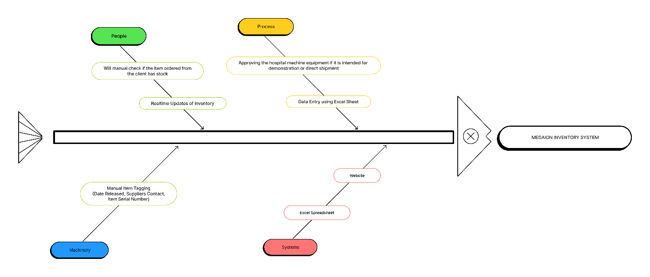Figure 1
Moving forward, we utilized the Fishbone diagram to gain a clearer understanding of the causes and effects influencing the MEGAION company as shown in the image above.

Proposed Solution

4.2 Lean Canvas

4.2.1 Problem

- Manual process of tracking stock levels for delivery or demonstration of machines, leading to potential delays
- To ensure optimal inventory and prevent sales disruptions caused by understocking in a B2B supply chain.
- Outdated and inefficient process of machine retrieval after demonstration.
4.2.2 Solution

1. To reduce the delay of checking stock levels for items that are for delivery or demonstration by 85%.
2. To ensure optimal inventory and prevent sales disruptions caused by understocking.
3. To streamline the process for retrieving and logging demonstration machines to mitigate instances of missing stock.

4.2.3 Key Metrics

- Customer Satisfaction
- Customer Retention
- Return of Investment

4.2.4 Unique Value Proposition
- AI forecasting and automated data cleaning
- Advanced Parts Traceability
- Minimized Human Error
- Visual Representation of Sales
- Downloadable Reports
- Adaptation to all devices

4.2.5 Customer Segment

- Hospitals
- Health Care Organizations
- Educational Institutions

4.2.6 Channels

- Conferencing Platforms (Google Meet)
- E-mail
- Face to Face Interviews

4.2.7 Revenue Streams

- One time Payment
- Support and Maintenance of Application

4.2.8 Cost Structure

- Hosting Costs
- Barcode Scanners
- Sensors
- Development Costs

4.2.9 Unfair Advantage
- Customization and Flexibility
- Data Analytics

4.3 Product Vision

To innovate the efficiency and accuracy of the megaion medical equipment management operations by developing an integrated inventory management and supply chain management system equipped with a barcode management solution that has ai. This will enable real-time tracking of inventory, streamline supply processes, time efficient, and improve overall customer satisfaction.

Table 3 Product Vision

For: Megaion Inventory and logstics
Who: Has the responsibility for monitoring the inventory and determining whether the equipment is for delivery, demo, or just inventory
The: DHAN System
That: Monitors the inventory, has a supply chain management system, a barcode scanning and ai feature
Unlike: The traditional method for them to use pen and paper and google sheets before putting it in excel.
Our: Inventory system will be more efficient and less time consuming for the user

4.4 Technology Specifications

The project will be used as a tool that will only focus on the client’s needs. Moreover, the team proposed to create an inventory system that will solve the client’s problems. This system will use barcode scanning to see if an item is for demonstration or for delivery. For now, the developers plan to develop the project using HTML, CSS, JS, SQL, PHP, PYTHON, Visual studio, Pandas Python and AdminLTE. Initially, the project will be developed to address the client’s current needs. In future development, more features would be added such as AI, invoice printing, order management screen, and improved notification systems. Lastly, the system will have a customizable dashboard wherein you can access data insights that can be exported into detailed reports.

Pandas is a Python library designed for data manipulation and analysis. It offers fast and flexible data structures like Series and DataFrame, similar to tables in databases, for handling large datasets. Pandas supports operations such as data alignment, handling missing data, and reshaping datasets. Accurate demand forecasting is crucial for optimizing inventory levels in supply chain management, preventing overstock or stockout situations. By analyzing historical data, industry trends, and consumer behavior, organizations can enhance forecasting accuracy. Python provides libraries for statistical operations, data visualization, and predictive modeling, aiding in informed decision-making for inventory management​.

The system will also make use of PubNub for real-time item tracking. In order to deliver current information on the location and status of things, PubNub provides real-time messaging and data streaming features. By ensuring that all parties involved have access to the most recent information, better decision-making and more effective operations are made possible.

The following is the category and specifications needed to develop the project:

Table 4 List of Category and Specifications

Category | Specifications
Hardware | - Barcode Scanners  - Computer/Laptop  - Router
Software | - MySQL  - AdminLTE  - Visual studio  - Python Panda  - PubNub  - JavaScript
Peopleware | - Project Members  - Project Adviser  - Project Consultant  - Client
Network | - Wide Area Network (WAN)

4.5 Feasibility

4.5.1 Technical Feasibility

The project will be implemented with tools that can increase the system's efficiency. The project’s compiler will be VS code with JavaScript and PHP as it’s main language. With JavaScript, there would be a lot of libraries that can be used e.g (jQuery, MorrisJS, ChartJS) to increase the functionality of the system. AdminLTE would also be used because it is made for creating admin panels, dashboards, and back-end user interfaces. All of the tools given would be used to develop the system.

4.5.2 Market Feasibility
The client’s main problem, which is the monitoring of items that goes in and out of the inventory, it shows that inefficiency and human errors are the main concern. With this project, the efficiency of handling the inventory will surely increase and will reduce human errors. The marketable feasibility for the project is to greatly improve the handling of inventory, thus helping employees save time and reduce potential errors. Employees can now focus on advertising their products and accommodating more customers.

4.5.3 Operational Feasibility
The client and its employees fully support and believe that this project will solve their current issues in inventory operations. According to the client, there are times they encounter conflicts in their inventory due to unorganized excel sheets. This project will help the client organize their needs by simply downloading excel sheets from sales reports provided by the system. Furthermore, the developers will provide a tutorial to the employees on how to use the system. The group will be open to any suggestions the client gives to improve the user-friendliness of the said system.

Requirements Analysis

Product Backlog / User Stories

Table 5 Product Backlog
DHAN INVETORY SYSTEM
ID | As a.. | I want to be able to.. | So that.. | Priority | Status
1 | Inventory staff | Scan equipment’s using barcodes | I can quickly add them to the inventory system | Must | Not yet started
2 | Inventory staff | Use AI to forecast inventory restock needs | I can maintain optimal stock levels | Must | Not yet started
3 | Inventory staff | Generate barcodes | Each equipment is uniquely identifiable | Must | Not yet started
4 | Inventory staff | Receive low stock alerts | I can order items before they run out | Must | Not yet started
5 | Inventory staff | Track the equipment’s status | I know if the equipment is for delivery/demo/stock/rent/borrowed | Should | Not yet started
6 | Inventory staff | Access a dashboard for inventory supplies | I can monitor the equipment’s status in real-time | Must | Not yet started
7 | Inventory staff | Use AI for predictive analytics | I can optimize inventory based on the equipment stocks | Must | Not yet started
8 | Inventory staff | Receive notification via email | I can know if we are on low stocks on a certain equipment | Must | Not yet started
9 | Inventory staff | Use AI assistance | It can help the staff to predict stock shortages and optimize inventory levels | Must | Not yet started

Use Case Diagram

Figure 2 Use Case Diagram
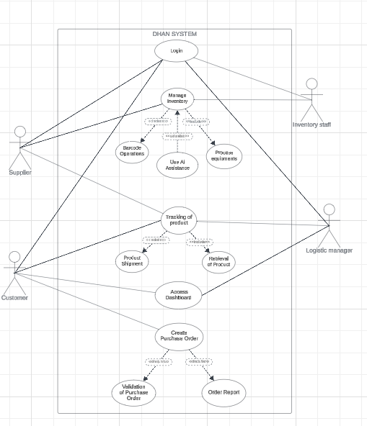

5.3 Data Flow Diagram

Figure 11 Level 0 of Data Flow Diagram
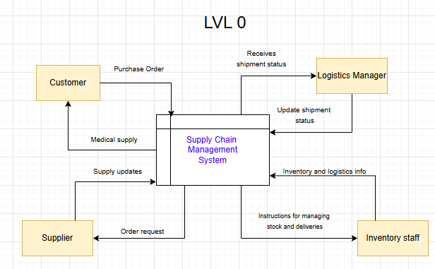

Figure 12 Level 1 Megaion Supply Chain Management System
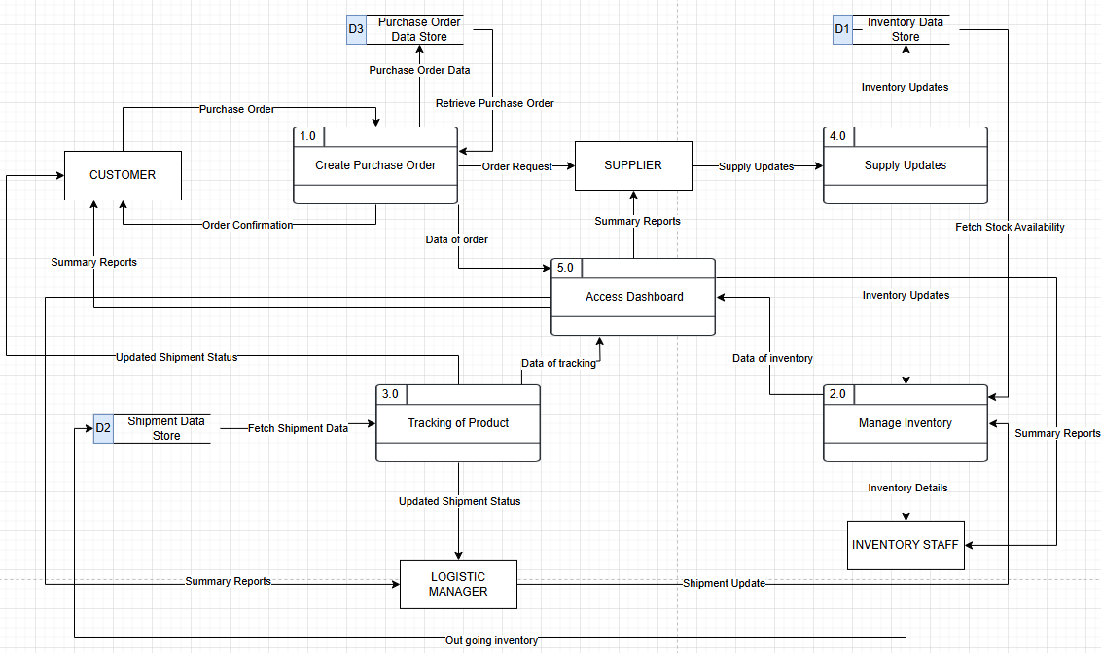

Figure 13 Level 2 Process 1.0 Create Purchase Order
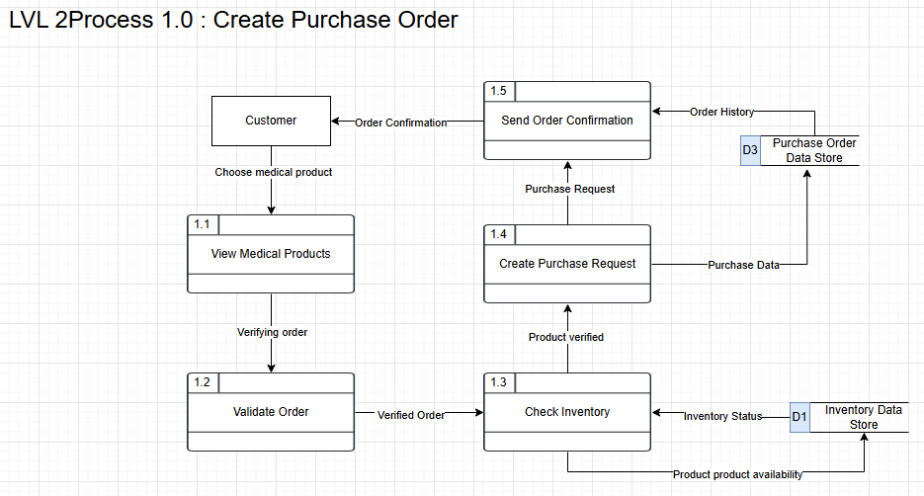
Figure 14 Level 2 Process 2.0 Manage Inventory
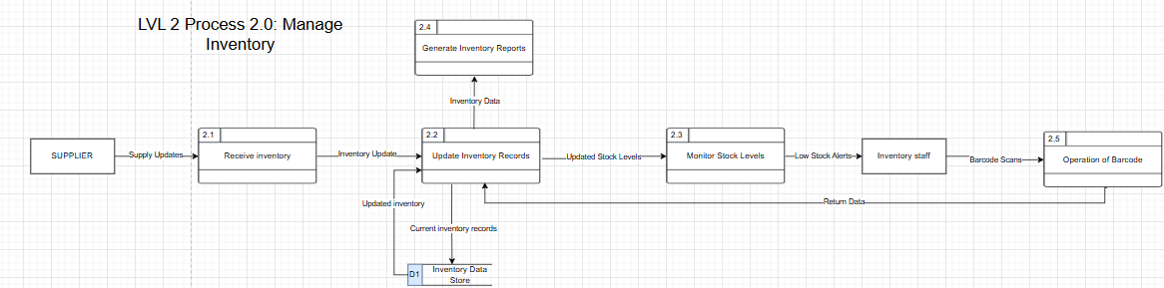
Figure 15 Level 2 Process 3.0 Tracking of Procuct
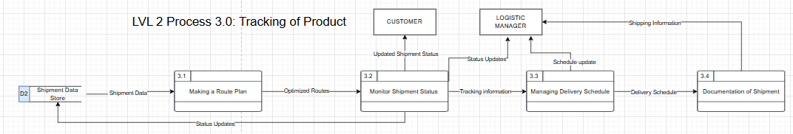

Figure 16 Level 2 Process 4.0 Supply Updates
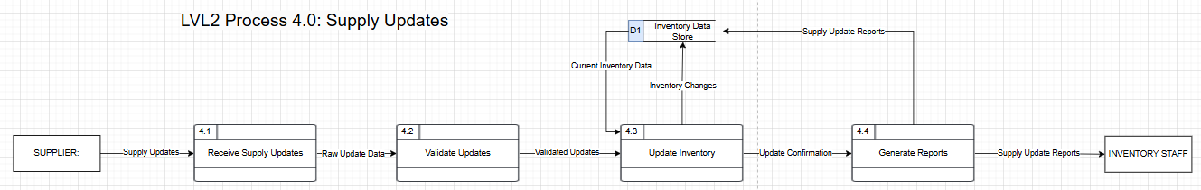
Figure 17 Level 2 Process 5.0 Access Dashboard
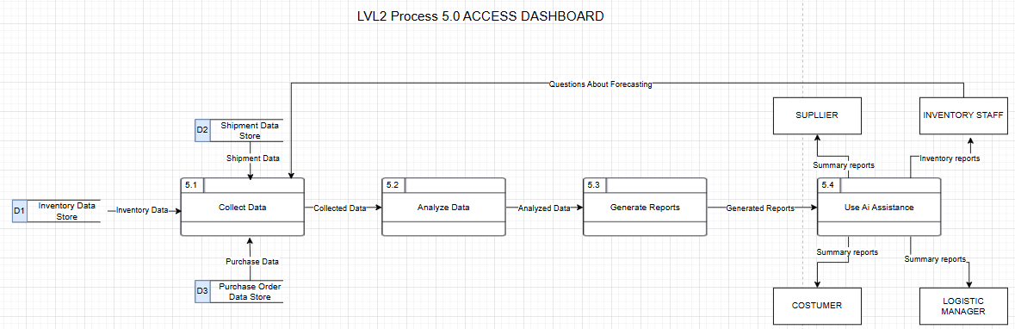

Figure 18 Level 2 Process 6.0 Using AI ASSISTANCE
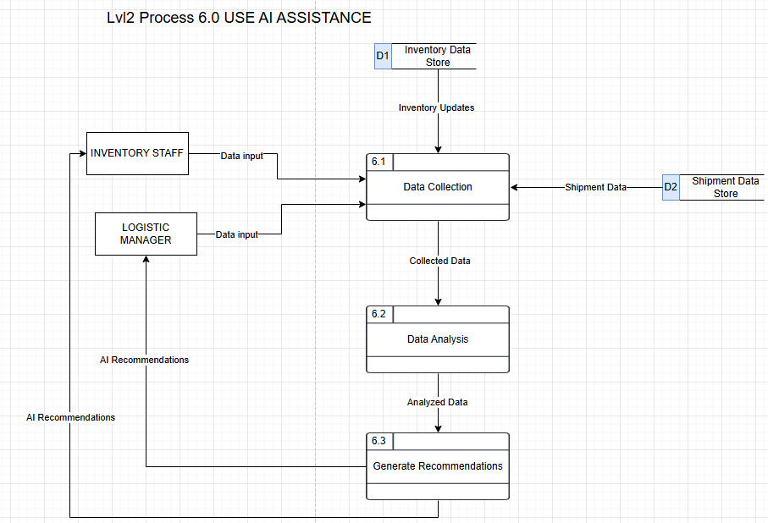

5.4 Fully Dressed Use Case
Use Case ID: | UCF-01
Use Case Name: | Login
Created By: | DHAN
Date created: | N/A
Description: | The Inventory staff, supplier, customer and Logistics manager are required to login to their accounts to have access in the system.
Primary Actors: | Inventory staff, and Logistics manager.  Customer and supplier
Secondary Actors: | None
Pre-Conditions: | 1. It is required to be done to use the system.
Post-Conditions: | 1. The user can now access the system.  2. Upon logging in the user is now on the home page of the system.
Main scenario: | 1. The user is required to login.  2. The user will login with his/her username and password.  3. The system will check if the username and password is valid.  4. The user can now use the system.

Use Case ID: | UCF_02
Use Case Name: | Access Dashboard
Created By: | DHAN
Date created: | N/A
Use Case Description: | The dashboard is for the users. The dashboard is for them to view certain info in the system.
Primary Actors: | Inventory staff, logistics manager, customer and supplier
Secondary Actors: | None
Pre-Conditions: | 1. The user needs to log in to the system  2. The system validates the users access
Post-Conditions: | 1. The user views real-time data and statistics.  2. Notifications are displayed on the dashboard.
Main scenario: | 1. The user selects the "Access Dashboard" option from the system.  2. The system loads and displays relevant data, such as inventory levels and shipment statuses.  3. The user views the dashboard and can click on specific items for more detail.  4. The system updates the dashboard in real-time.

Use Case ID: | UCF_03
Use Case Name: | Manage Inventory
Created By: | DHAN
Date created: | N/A
Use Case Description: | The Inventory Staff is responsible for managing the inventory of medical equipment. They can add, update and remove inventory items and ensure the stock levels are accurate.
Primary Actors: | Inventory staff
Secondary Actors: | None
Pre-Conditions: | 1. The user must be logged into the system.  2. The user must have permission to manage inventory.
Post-Conditions: | 1. The inventory has been successfully updated.  2. All stock changes are reflected in the system and are accessible to authorized users.
Main scenario: | 1. The user selects the "Manage Inventory" option from the dashboard.  2. The system displays a list of current inventory items, including item details and stock levels.  3. The user selects an inventory item to modify.  4. The system prompts the user to either:  - Add a new inventory item.  - Update an existing.  - Remove an item from the inventory.  5. The user inputs the necessary changes and submits the form.  6. The system validates the changes and updates the inventory records.  7. The user receives a confirmation that the inventory has been updated.  8. The system logs the changes for audit purposes.

Use Case ID: | UCF_04
Use Case Name: | Process equipment
Created By: | DHAN
Date created: | N/A
Use Case Description: | Inventory Staff and Logistics manager can process equipment, ensuring that it is properly prepared, tracked, and assigned to inventory locations.
Primary Actors: | Logistics Manager, Inventory Staff
Secondary Actors: | None
Pre-Conditions: | 1. The user must be logged into the system.  2. The user must have permission to process equipment.
Post-Conditions: | 1. Equipment has been processed and updated in the system.  2. The equipment status has been updated.
Main scenario: | 1. The user selects the "Process Equipment" option.  2. The system displays the list of equipment pending processing.  3. The user selects an equipment item to process.  4. The system prompts the user for details.  5. The user submits the equipment details.  6. The system validates the information and updates the equipment status.  7. The user receives a confirmation that the equipment has been processed.

Use Case ID: | UCF_05
Use Case Name: | Use Barcode Operations
Created By: | DHAN
Date created: | N/A
Use Case Description: | Inventory Staff can scan and manage barcodes for inventory items, allowing them to efficiently update inventory status and locations.
Primary Actors: | Inventory Staff
Secondary Actors: | None
Pre-Conditions: | 1. The user must be logged into the system.  2. The system must be connected to a barcode scanner.  3. The user must have permission to manage barcode operations.
Post-Conditions: | 1. Barcode has been successfully scanned and associated with an inventory item.  2. The inventory item’s status or location is updated.
Main scenario: | 1. The user selects the "Barcode Operations" option.  2. The system prompts the user to scan a barcode.  3. The user scans the barcode.  4. The system verifies the barcode and retrieves the associated inventory item.  5. The user confirms or updates the item's status or location.  6. The system saves the changes and provides a confirmation.

Use Case ID: | UCF_06
Use Case Name: | Ai Assistance
Created By: | DHAN
Date created: | N/A
Use Case Description: | The system provides AI-based suggestions and support to help and Inventory Staff with inventory management and decision-making.
Primary Actors: | Inventory Staff
Secondary Actors: | None
Pre-Conditions: | 1. The user must be logged into the system.  2. AI functionality must be enabled and trained with sufficient data.
Post-Conditions: | 1. The AI provides relevant suggestions or reports based on the user's data gave.
Main scenario: | 1. The user selects the "AI Assistance" option.  2. The system asks the user to input a query or select a task.  3. The user submits the request.  4. The AI analyzes data and provides recommendations or insights.  5. The user reviews the AI's suggestions and takes action accordingly.

Use Case ID: | UCF_07
Use Case Name: | Tracking of Product
Created By: | DHAN
Date created: | N/A
Use Case Description: | The Logistics manager, Supplier and Customer can track the status and location of products.
Primary Actors: | Supplier, Customer and logistics manager
Secondary Actors: | None
Pre-Conditions: | 1. The user must be logged into the system.  2. The product must have been shipped and be available for tracking.
Post-Conditions: | 1. The user receives up-to-date information about the product’s status and location.
Main scenario: | 1. The user selects the "Tracking of Product" option.  2. The system prompts the user to enter a product tracking number or select an order.  3. The system retrieves the product’s current status and location.  4. The user views the tracking details on the dashboard.

Use Case ID: | UCF_8
Use Case Name: | Create Purchase Order
Created By: | DHAN
Date created: | N/A
Use Case Description: | The customer can place orders for medical equipment and supplies via the system.
Primary Actors: | Customer
Secondary Actors: | None
Pre-Conditions: | 1. The user must be logged into the system.  2. The user must have the necessary permissions to place an order.
Post-Conditions: | 1. The order is placed and confirmed in the system.  2. The order details are sent to MEGAION for fulfillment.
Main scenario: | 1. The user selects the "Place Order" option.  2. The system prompts the user to select products and enter order quantities.  3. The user reviews the order details and submits the order.  4. The system confirms the order and notifies MEGAION.  5. The user receives a confirmation with the order number and expected delivery date.

Use Case ID: | UCF_9
Use Case Name: | View Product Shipment
Created By: | DHAN
Date created: | N/A
Use Case Description: | The customer can view the shipment status of ordered products.
Primary Actors: | Customer
Secondary Actors: | None
Pre-Conditions: | 1. The user must be logged into the system.  2. The user must have placed an order and have the order ID.
Post-Conditions: | 1. The shipment details are displayed to the customer.  2. The user is informed of the estimated delivery date.
Main scenario: | 1. The user selects the "View Shipment Status" option.  2. The system prompts the user to enter the order ID.  3. The user enters the order ID and submits the request.  4. The system retrieves the shipment information and displays it.  5. The user views the current location and expected delivery date of the product.

Use Case ID: | UCF_10
Use Case Name: | View Retrieval of Product
Created By: | DHAN
Date created: | N/A
Use Case Description: | The customer can view the retrieval status of products.
Primary Actors: | Customer
Secondary Actors: | None
Pre-Conditions: | 1. The user must be logged into the system.  2. The user must have the necessary permissions to view retrieval status.
Post-Conditions: | 1. The retrieval details are displayed to the customer.  2. The customer knows the status and availability of the product.
Main scenario: | 1. The user selects the "View Retrieval Status" option.  2. The system prompts the user to enter the retrieval request ID.  3. The user enters the ID and submits the request.  4. The system retrieves the current status and displays it to the user.  5. The user reviews the status of the retrieval process

Use Case ID: | UCF_11
Use Case Name: | View Purchase Order
Created By: | DHAN
Date created: | N/A
Use Case Description: | The customer can view the details of their purchase orders.
Primary Actors: | Customer
Secondary Actors: | None
Pre-Conditions: | 1. The user must be logged into the system.  2. The user must have placed an order.
Post-Conditions: | 1. The purchase order details are displayed to the customer.
Main scenario: | 1. The user selects the "View Purchase Order" option.  2. The system prompts the user to enter the order ID or select from recent orders.  3. The user selects the order and submits the request.  4. The system retrieves the order details and displays them.  5. The user reviews the items, quantities, and status of the purchase order.

Use Case ID: | UCF_12
Use Case Name: | View Order Report
Created By: | DHAN
Date created: | N/A
Use Case Description: | The customer can view a summary report of all orders placed within a specified timeframe.
Primary Actors: | Customer
Secondary Actors: | None
Pre-Conditions: | 1. The user must be logged into the system.  2. The user must have placed at least one order.
Post-Conditions: | 1. The order report is displayed to the customer, showing order details and statuses.
Main scenario: | 1. The user selects the "View Order Report" option.  2. The system prompts the user to enter a date range for the report.  3. The user enters the date range and submits the request.  4. The system retrieves the order history within the specified timeframe.  5. The user reviews the report, which shows all orders, statuses, and totals.

5.5 Test Cases

Test Case ID |  | 01 | Test Case Description |  | Test the login functionality for various types of users. |  | Version |  | 1.0
Created By |  |  | Reviewed By
QA Tester’s Log |  |  |  |  | Verified all scenarios, including valid and invalid login attempts. Results matched expected outcomes.
Tester’s Name |  |  | Date Tested |  |  |  | Test Case  (Pass/Fail/Not)
S # |  | Prerequisites: |  |  | S # | Test Data
1 |  | Valid user credentials are available for testing. |  |  | 1 | Inventory Staff  Username: ****  Password: ****
2 |  | System is accessible via the web. |  |  | 2 | Supplier  Username: ****  Password: ****
 |  |  |  |  | 3 | Customer  Username: ****  Password: ****
 |  |  |  |  | 4 | Logistics Manager  Username: *****  Password: *****
Test Scenario |  |  |  |  | - Verify successful login with valid credentials and display of proper error messages for invalid credentials.  - Verify error message when invalid credentials are entered.  - Verify prompts for required fields when credentials are not entered.
Step # | Step Details |  |  | Expected Results |  | Actual Results |  | Pass / Fail / Not executed / Suspend
1 | Navigate to the login page. |  |  | - The login page is displayed successfully.  - User is successfully logged in and redirected to the home page.  - System displays error message: "Invalid username or password."  - System prompts: "Please enter both username and password."
2 | Enter valid credentials for each user type (Inventory Staff, Supplier, etc.).
3 | Enter invalid credentials.
4 | Attempt login without entering credentials.

Test Case ID |  | 02 | Test Case Description |  | Verify that users can view the dashboard after login. |  | Version |  | 1.0
Created By |  |  | Reviewed By
QA Tester’s Log |  |  |  |  | All dashboard views loaded correctly; real-time data was accurate as per requirements.
Tester’s Name |  |  | Date Tested |  |  |  | Test Case  (Pass/Fail/Not)
S # |  | Prerequisites: |  |  | S # | Test Data
1 |  | User must be logged into the system. |  |  | 1 | Inventory Staff  Username: inventory_user
2 |  | User has the necessary permissions to view the dashboard. |  |  | 2 | Logistics Manager  Username: logistics_user
 |  |  |  |  | 3
 |  |  |  |  | 4
Test Scenario |  |  |  |  | - Verify the dashboard is displayed for authorized users.  - Verify real-time data and statistics are visible.
Step # | Step Details |  |  | Expected Results |  | Actual Results |  | Pass / Fail / Not executed / Suspend
1 | Log in as an inventory staff or logistics manager. |  |  | - The dashboard page is displayed with relevant real-time data and statistics.  - Data is displayed accurately, and all dashboard elements are responsive.  - Data is displayed correctly, and users can interact with elements.
2 | Navigate to the "Dashboard" option in the system.
3 | View and interact with the dashboard data.
4

Test Case ID |  | 03 | Test Case Description |  | Verify inventory management functionality (add, update, remove items). |  | Version |  | 1.0
Created By |  |  | Reviewed By
QA Tester’s Log |  |  |  |  | Verified that data integrity is preserved, and all CRUD actions on inventory items have been tested.
Tester’s Name |  |  | Date Tested |  |  |  | Test Case  (Pass/Fail/Not)
S # |  | Prerequisites: |  |  | S # | Test Data
1 |  | User must be logged into the system. |  |  | 1 | Inventory Staff  Username: inventory_user
2 |  | User has permission to manage inventory. |  |  | 2
 |  |  |  |  | 3
 |  |  |  |  | 4
Test Scenario |  |  |  |  | - Verify that users can add, update, or remove inventory items.  - Verify that changes are saved and displayed correctly.
Step # | Step Details |  |  | Expected Results |  | Actual Results |  | Pass / Fail / Not executed / Suspend
1 | Log in as inventory staff. |  |  | - Inventory management page is displayed showing current inventory items.  - The system shows the inventory items with details like stock levels.  - Changes are reflected correctly in the system and confirmation provided.
2 | Navigate to "Manage Inventory" option.
3 | Add, update, or remove an inventory item.
4

Test Case ID |  | 04 | Test Case Description |  | Ensure equipment processing functionality. |  | Version |  | 1.0
Created By |  |  | Reviewed By
QA Tester’s Log |  |  |  |  | Verify that equipment processing steps completed as expected; all status updates were logged correctly.
Tester’s Name |  |  | Date Tested |  |  |  | Test Case  (Pass/Fail/Not)
S # |  | Prerequisites: |  |  | S # | Test Data
1 |  | User must be logged into the system. |  |  | 1 | Username: inventory_user
2 |  | User must have permission to process equipment. |  |  | 2
 |  |  |  |  | 3
 |  |  |  |  | 4
Test Scenario |  |  |  |  | - Verify that users can process equipment and update its status.
Step # | Step Details |  |  | Expected Results |  | Actual Results |  | Pass / Fail / Not executed / Suspend
1 | Log in as inventory staff. |  |  | - System displays a list of equipment pending processing.  - The system shows available options to process equipment.  - Equipment status is updated successfully and confirmation is displayed.
2 | Select "Process Equipment" from the menu.
3 | Process an equipment item by providing details.
4

Test Case ID |  | 05 | Test Case Description |  | Verify barcode management functionality (scan and update status/location). |  | Version |  | 1.0
Created By |  |  | Reviewed By
QA Tester’s Log |  |  |  |  | Barcode scanning and status updates performed correctly; all barcodes matched
Tester’s Name |  |  | Date Tested |  |  |  | Test Case  (Pass/Fail/Not)
S # |  | Prerequisites: |  |  | S # | Test Data
1 |  | User must be logged into the system. |  |  | 1 | Inventory Staff  Username: inventory_user
2 |  | System must be connected to a barcode scanner. |  |  | 2
3 |  | User must have permission to manage barcode operations. |  |  | 3
 |  |  |  |  | 4
Test Scenario |  |  |  |  | - Verify that users can scan barcodes and update inventory item status or location.
Step # | Step Details |  |  | Expected Results |  | Actual Results |  | Pass / Fail / Not executed / Suspend
1 | Log in as inventory staff. |  |  | - System prompts user to scan a barcode.  - System verifies the barcode and retrieves the associated inventory item.  - Changes are saved, and the system provides confirmation.
2 | Select "Barcode Operations" and initiate barcode scan.
3 | Scan barcode and update item's status/location.
4

Test Case ID |  | 06 | Test Case Description |  | Verify AI-based suggestions and support. |  | Version |  | 1.0
Created By |  |  | Reviewed By
QA Tester’s Log |  |  |  |  | Ensure AI suggestions were relevant and timely; system performance was optimal during AI operations.
Tester’s Name |  |  | Date Tested |  |  |  | Test Case  (Pass/Fail/Not)
S # |  | Prerequisites: |  |  | S # | Test Data
1 |  | User must be logged into the system. |  |  | 1 | Inventory Staff  Username: inventory_user
2 |  | AI functionality must be enabled and trained with sufficient data. |  |  | 2
 |  |  |  |  | 3
 |  |  |  |  | 4
Test Scenario |  |  |  |  | - Verify that the AI provides relevant suggestions based on user queries.
Step # | Step Details |  |  | Expected Results |  | Actual Results |  | Pass / Fail / Not executed / Suspend
1 | Log in as inventory staff. |  |  | - System processes the request and provides relevant AI-based suggestions.  - AI provides accurate suggestions based on the task or query.  - AI suggestions are actionable and relevant to the context.
2 | Access "AI Assistance" option and input query.
3 | Review AI suggestions and take action accordingly.
4

Test Case ID |  | 07 | Test Case Description |  | Verify product or shipment tracking functionality. |  | Version |  | 1.0
Created By |  |  | Reviewed By
QA Tester’s Log |  |  |  |  | Ensure that tracking feature works as expected; ensure all tracking details are accurate and up to date.
Tester’s Name |  |  | Date Tested |  |  |  | Test Case  (Pass/Fail/Not)
S # |  | Prerequisites: |  |  | S # | Test Data
1 |  | User must be logged into the system. |  |  | 1 | Inventory Staff  Username: inventory_user
2 |  | Product must have been shipped and available for tracking. |  |  | 2 | Customer  Username: customer_user
 |  |  |  |  | 3 | Logistics Manager  Username: logistics_user
 |  |  |  |  | 4
Test Scenario |  |  |  |  | - Verify users can track products or shipments.
Step # | Step Details |  |  | Expected Results |  | Actual Results |  | Pass / Fail / Not executed / Suspend
1 | Log in with appropriate user credentials. |  |  | - System prompts for tracking number or order selection.  - System displays current status and location of the product accurately.  - Product's status and location are updated and displayed accurately.
2 | Select "Tracking of Product" option.
3 | Enter tracking details and view status.
4

Test Case ID |  | 08 | Test Case Description |  | Verify purchase order functionality. |  | Version |  | 1.0
Created By |  |  | Reviewed By
QA Tester’s Log |  |  |  |  | Ensure orders were placed successfully; confirmation and order details were accurate.
Tester’s Name |  |  | Date Tested |  |  |  | Test Case  (Pass/Fail/Not)
S # |  | Prerequisites: |  |  | S # | Test Data
1 |  | Customer must be logged into the system |  |  | 1 | Customer  Username: customer_user
2 |  | Customer must have the necessary permissions to place an order. |  |  | 2
 |  |  |  |  | 3
 |  |  |  |  | 4
Test Scenario |  |  |  |  | - Verify customers can place orders for products.
Step # | Step Details |  |  | Expected Results |  | Actual Results |  | Pass / Fail / Not executed / Suspend
1 | Log in as a customer. |  |  | - Customer is authenticated successfully.  - System prompts for product selection and order quantity.  - Order is placed, and a confirmation message is displayed with details.
2 | Select "Place Order" option.
3 | Submit the order.
4

5.6 Activity Diagram with Swimlanes

Figure 19 SYSTEM LOGIN PROCESS
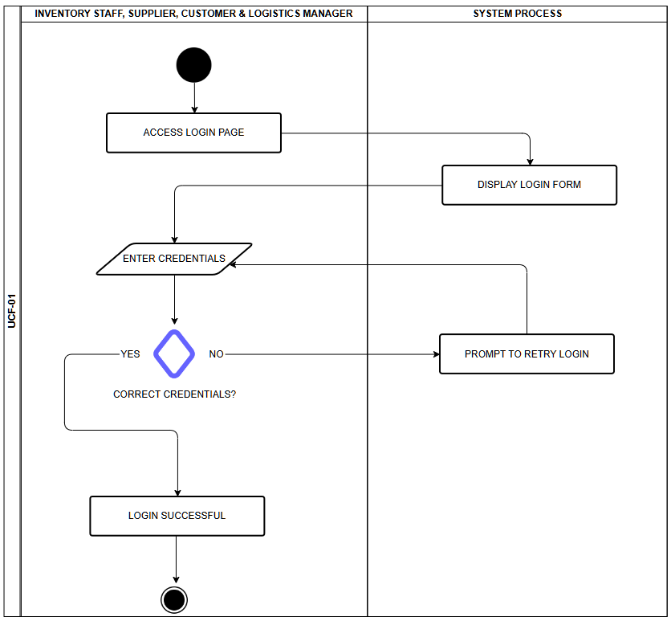

Figure 20 DASHBOARD SYSTEM
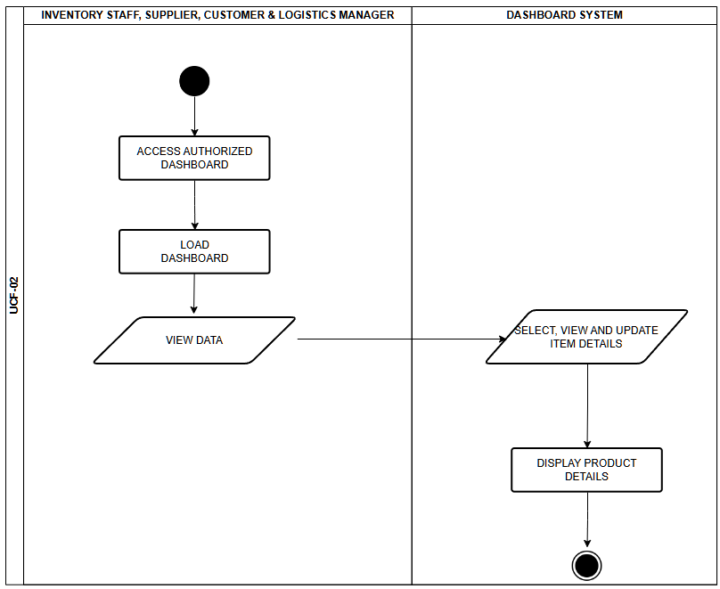

Figure 21 INVENTORY MANAGEMENT
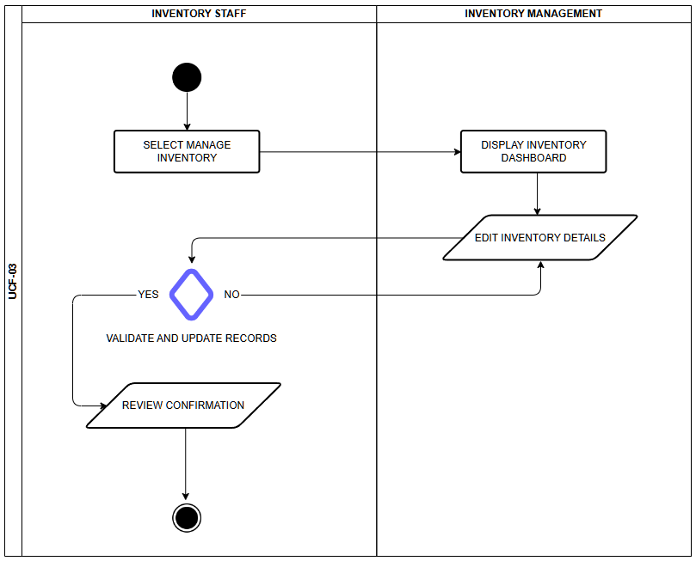

Figure 22 PROCESS EQUIPMENT
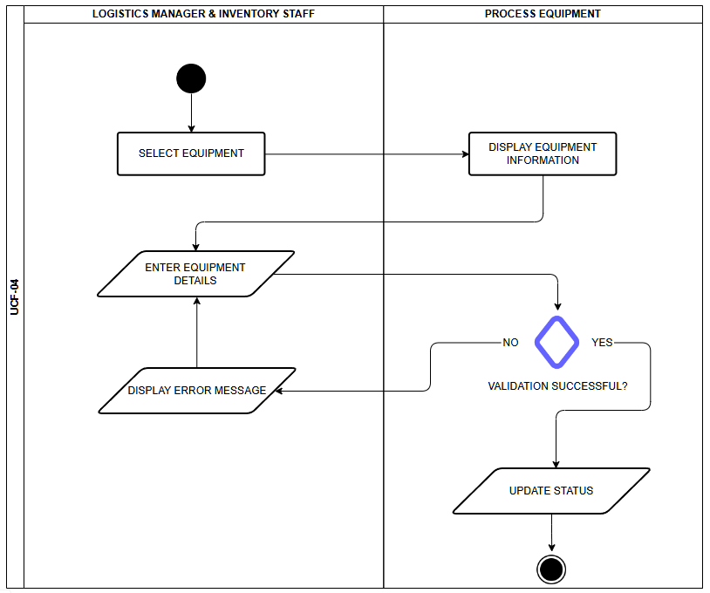

Figure 23 BARCODE OPERATIONS
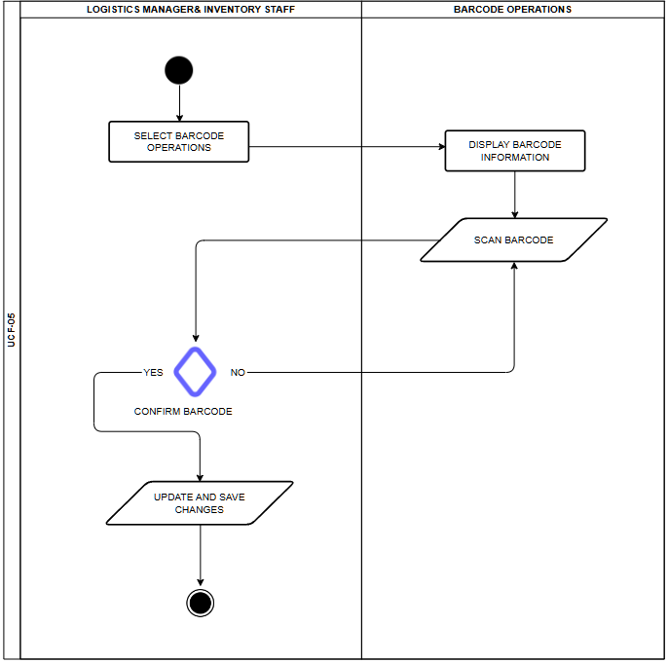

Figure 24 AI ASSISTANCE
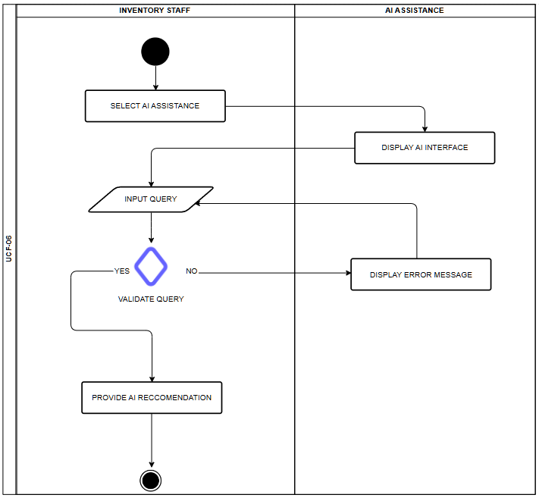

Figure 25 TRACKING OF PRODUCT
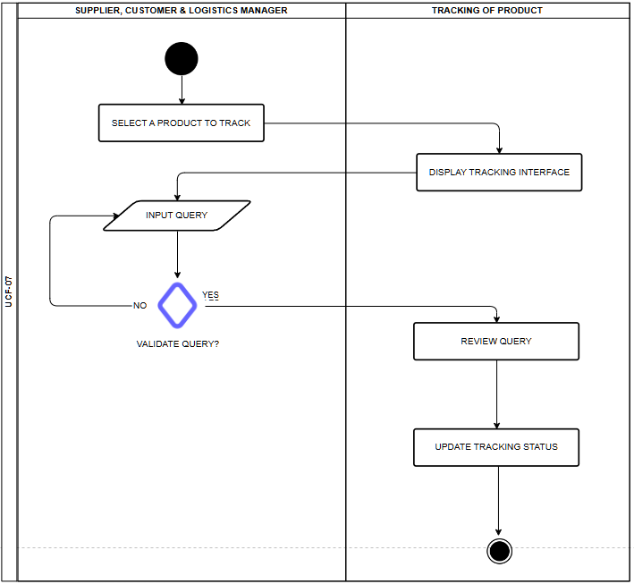

Figure 26 PURCHASE ORDER
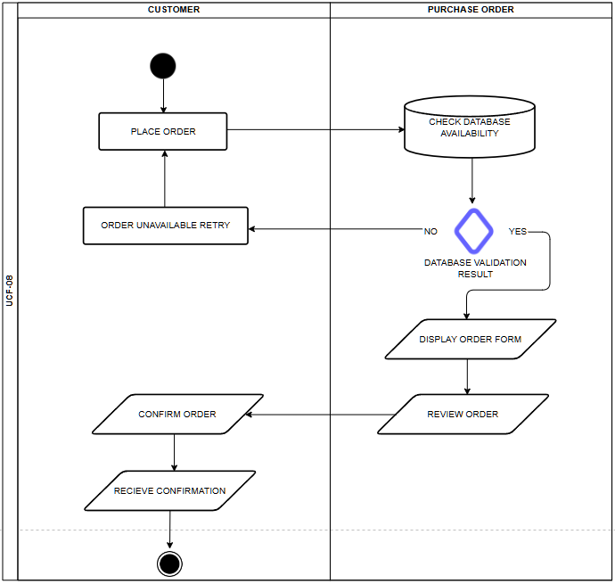

Figure 27 VIEW PRODUCT SHIPMENT
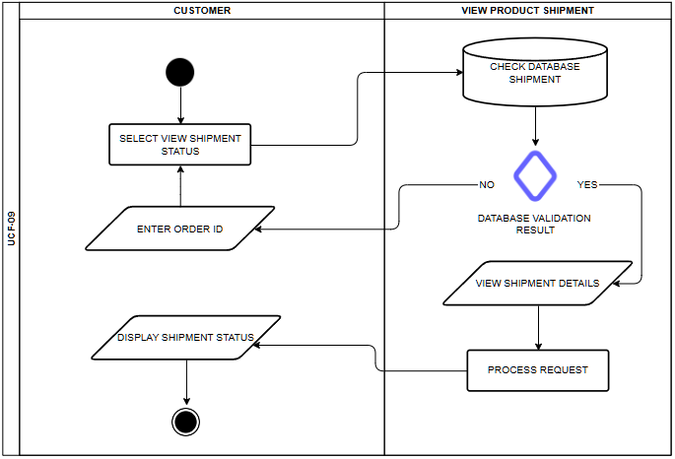

Figure 28 VIEW RETRIEVAL OF PRODUCT
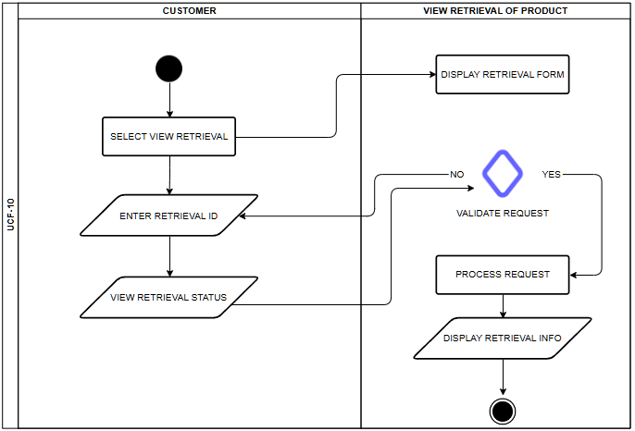

Figure 29 VIEW PURCHASE ORDER
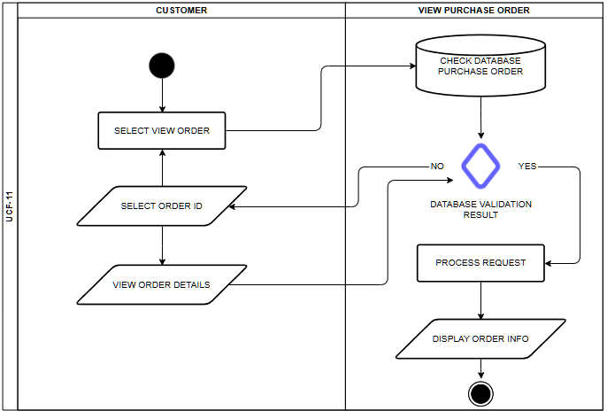

Figure 30 VIEW ORDER REPORT
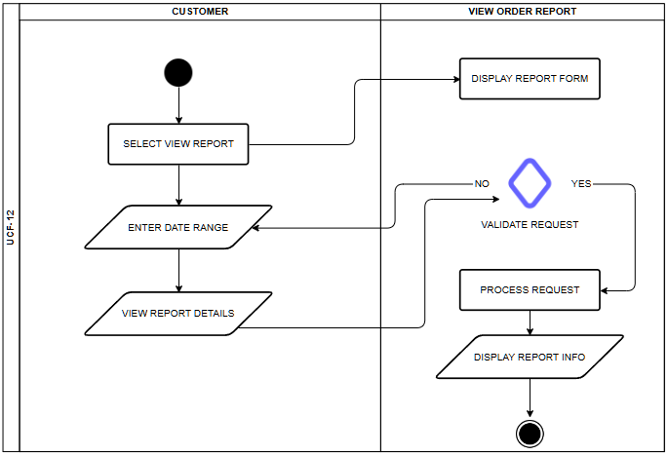
5.7 Entity Relationship Diagram

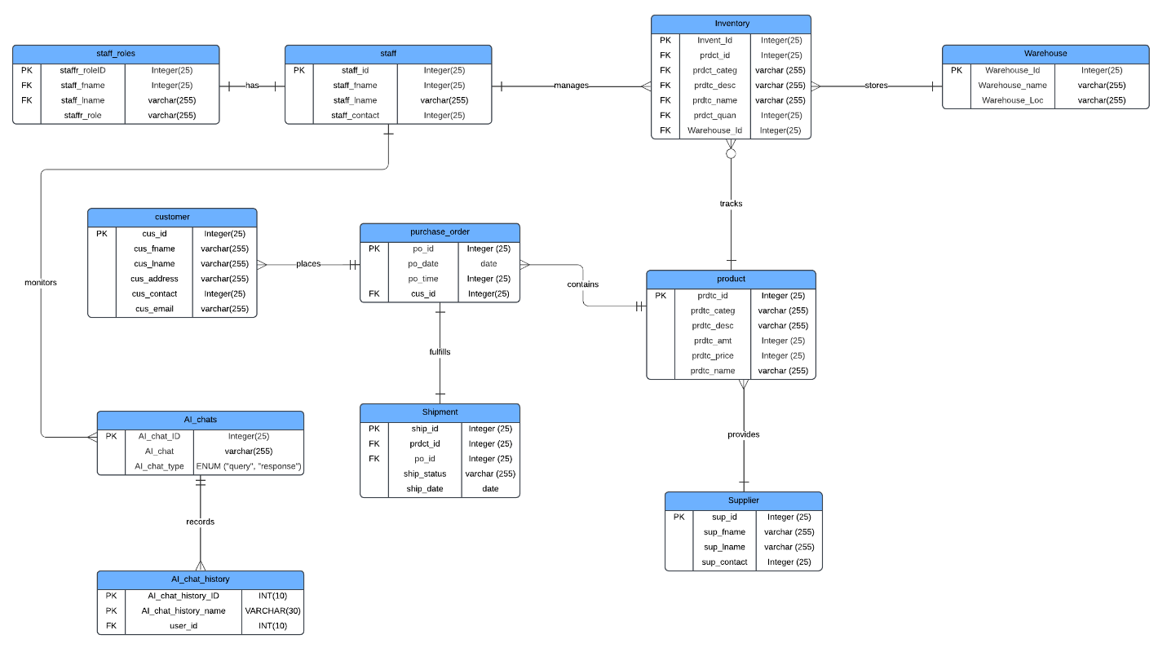

5.8 User Classes and Characteristics

Table 6 User Classes and Characteristics

Roles | Description
Logistics manager | The logistics manager is responsible for tracking the equipment's status and whereabouts.
Inventory Staff | This user has access to adding and deleting items for the inventory. They will also be the one to scan machine barcodes that would determine if a product is for demonstration or for delivery.
Supplier | The supplier can login, track shipments and can update the stock if it’s confirmed if the shipment is complete via shipment tracking and notification.
Customer | The customer can login in and can place their order. If its completed they can monitor it via tracking of the product and have a notification canceled or completed.

5.9 Prototype

Below is Figure 3 of the prototype login page. Only designated users of the system will be able to access it.


Figure 3 Login Page

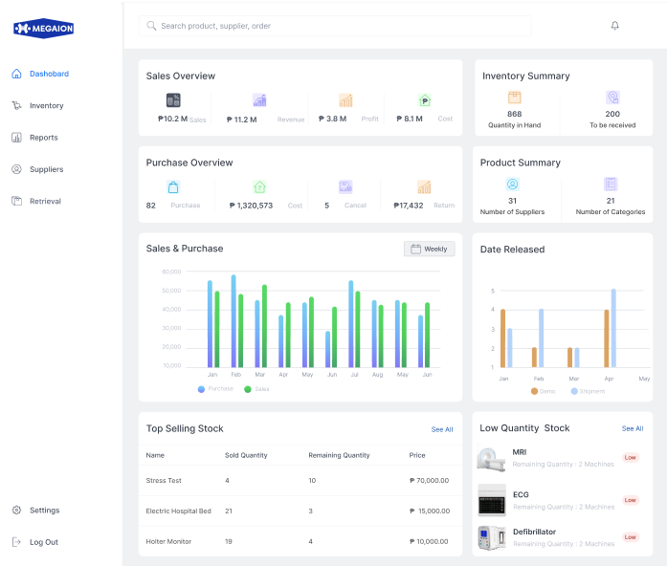
Figure 4 Landing Page
In Figure 4, The company's landing page leads to the Inventory System dashboard, where the users may view the sales overview, purchase overview, inventory summary, and product summary. Moreover, the dashboard will also show the top selling product and its date of release. Lastly, users would also know what products are low in quantity.

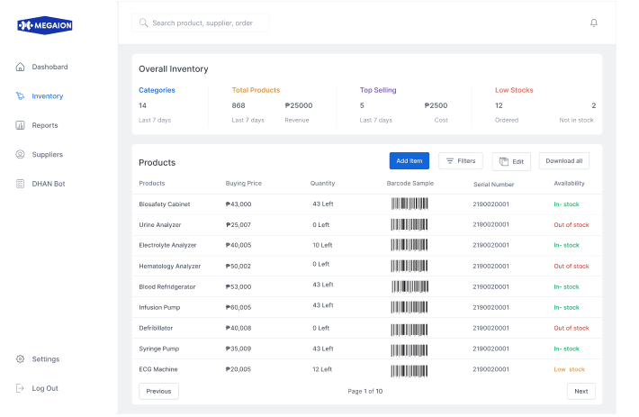

Figure 5 Inventory Tab
In Figure 5, this tab of the dashboard shows the overall products and the state of every equipment unit. It also shows the stock level status. After each product is entered, a unique barcode is automatically produced.

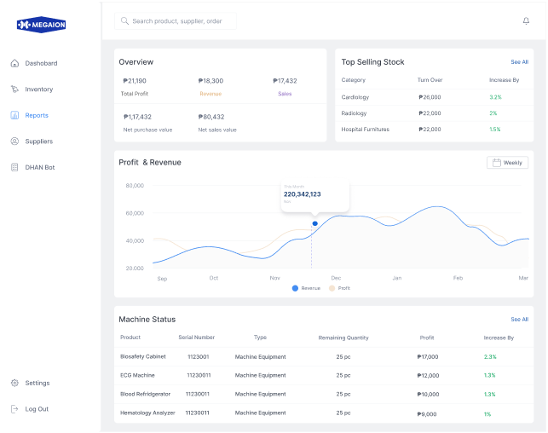
Figure 6 Reports Tab
In Figure 6, the use of predictive analytics in reports helps provide insights into potential future sales patterns.

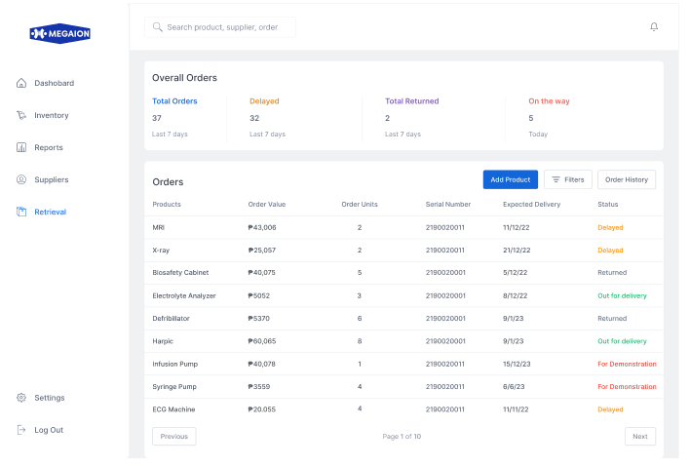
Figure 7 Shipment Status
In Figure 7, this section will display the shipment status of each in and out product. This allows the assigned staff of the inventory resource department to track the shipping status of products intended for clients.

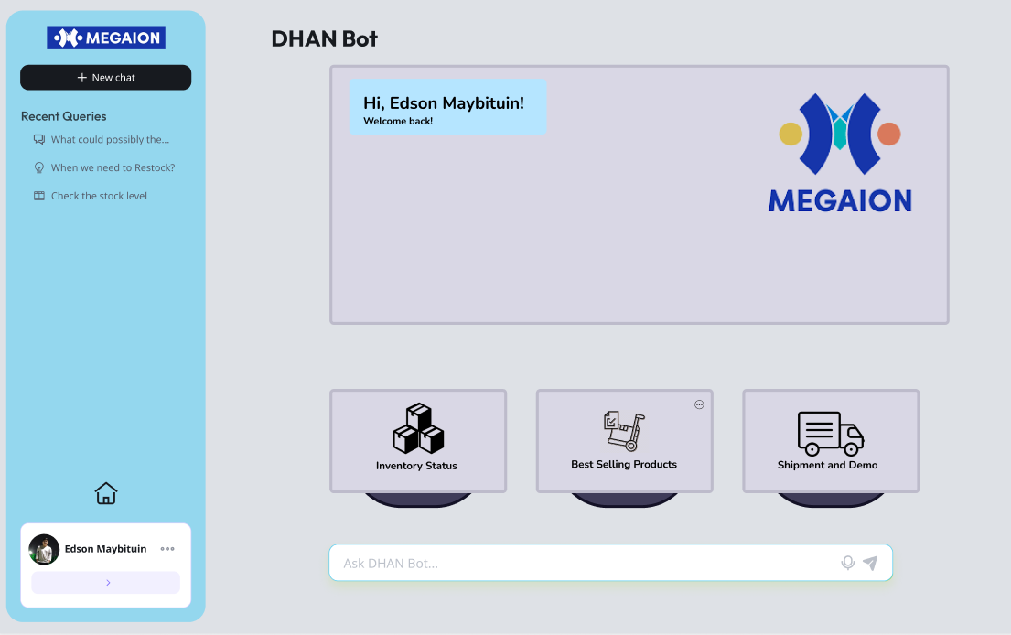
Figure 8 AI Module
In figure 8, this section will display the prototype AI module dashboard. The AI can help users track product demand, stock levels, and see graphs.

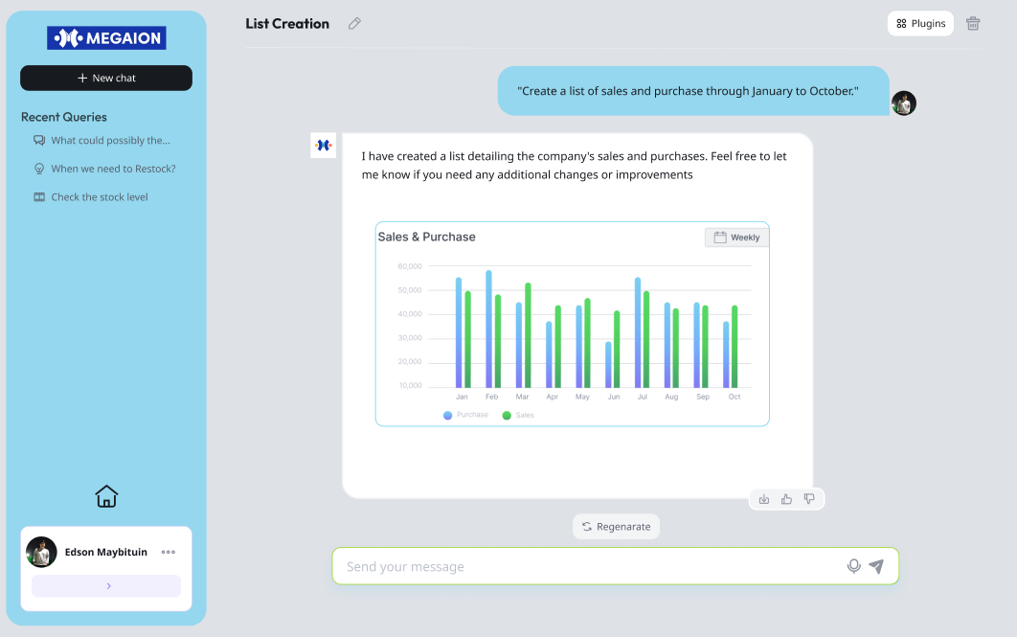
Figure 9 AI Module
In figure 9, this section will an example of an AI query that displays the company’s sales and purchases. The AI also provided a bar graph for users to know what they asked thoroughly.

5.10 Release Plan

Target Group: Megaion (Inventory department employees)
Goal: To improve operational system by implementing an advanced inventory system that integrates a supply chain management system, barcode system and AI capabilities. This system will streamline the process of tagging and tracking medical equipment, ensuring accurate and real time management of their inventory
Needs: A software solution that optimizes the working efficiency of the staff and assists in completing activities efficiently.
Value: To have a more accurate inventory management, improve the accuracy in tracking of their medical equipment’s and over all enhance their work efficiency
Key features:
- User log in
- Real-Time inventory updates
- Supply Chain Management System Integration
- AI assistance
- Barcode system
- Notification system
- Dashboard
- Product tracking
Release 1:
- Project documentation
- Creating project blueprint
- Project prototype design
Release 2:
- Database modeling
- Implement of database system planning and setup
- Developing wireframe and UI/UX design
- Research and design overall systems
Release 3:
- Implementation of Supply Chain Management System, AI module, and barcode systems with inventory management
- System testing
- Fix any bugs or defects
- Project deployment

References

- D. Budiac, “The Best Supply Chain Management Software,” softwareconnect, Mar. 04, 2024. https://softwareconnect.com/roundups/best-supply-chain-management-software/ (accessed Jul. 02, 2024).

- Ordoro, "Shipping Management," [Online]. Available: https://www.ordoro.com.
- Cin7, "Cloud-based Inventory Management," [Online]. Available: https://www.cin7.com.

- Odoo, "All-in-one Business Management Software," [Online]. Available: https://www.odoo.com.

- D. Grewal, J. Hulland, P. Kopalle, and E. Karahanna, “The future of technology and marketing: a multidisciplinary perspective,” link.springer, Dec. 17, 2019. https://link.springer.com/article/10.1007/s11747-019-00711-4? (accessed Jun. 09, 2024).
- A. Atieh, “Performance Improvement of Inventory Management System Processes by an Automated Warehouse Management System,” sciendedirect, 2016. https://www.sciencedirect.com/science/article/pii/S2212827115012019
(accessed Jun. 09, 2024).

- N. Istiqomah, P. Sansabilla, D. Himawan, and M. Rifni, “The Implementation of Barcode on Warehouse Management System for Warehouse Efficiency,” iopscience, 2020. https://iopscience.iop.org/article/10.1088/1742-6596/1573/1/012038 (accessed Jun. 09, 2024).
- “How to optimize supply chain management with Python: A Comprehensive Approach,” dataheadhunters, Feb. 15, 2024. https://dataheadhunters.com/academy/how-to-optimize-supply-chain-management-with-python-a-comprehensive-approach/ (accessed Jul. 07, 2024).

- M. Kuuse, “The Emerging Role of AI in Inventory Management (with Examples),” mrpeasy, Sep. 26, 2023. https://www.mrpeasy.com/blog/ai-inventory-management/? (accessed Jun. 24, 2024).

- “Role of GPS Tracking in Supply Chain Management,” analyticsinsight, Feb. 01, 2024. https://www.analyticsinsight.net/gps-tracking/role-of-gps-tracking-in-supply-chain-management (accessed Jul. 02, 2024).

Appendices

Appendix A: Project Vision

Our mission is to create an automated inventory management with a supply chain management system that will transform the accuracy and reduction of delay of MEGAION medical equipment warehouse operations. With the help of artificial intelligence (AI) and a sophisticated barcode management system, this system will be able to track inventories in real-time, streamline supply reports, and ultimately improve work efficiency.

This project began with client interviews and problem identification. This was followed by proposing a solution that will solve the client’s pain points. After proposing a solution, a brainstorming was made to think about what other features can be implemented in our system. The group made sure that the proposed features were inline with the client’s needs.

Appendix B: Schedule/Release Plan

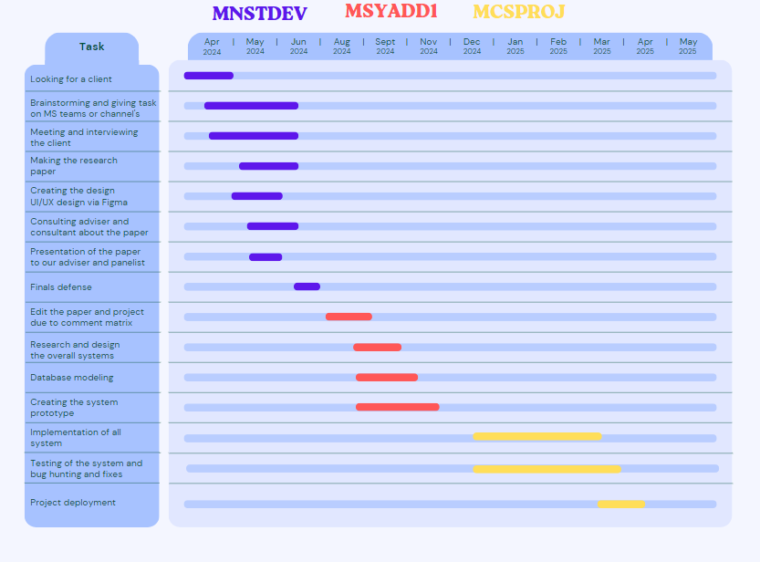
Figure 10 Schedule Plan

This project schedule plan will show our timeline to divide our task into three phases MNSTDEV, MSYADD1 and MSCPROJ making it one year from April 2024 to April 2025

Appendix C: Product Roadmap
(
Updated product roadmap file here. Make sure that content is readable
)
Table 7 Product Road Map

MNSTDEV | MSYADD1 | MCSPROJ
Milestone 1  - Looking for a client  - Brainstorming and delegating task on MS teams and messenger  Milestone 2  - Meeting and interviewing the client  - Making the research paper  - Creating the design UI/UX design via Figma  Milestone 3  - Consulting our adviser and consultant about the paper  - Presentation of the paper to our adviser and panelist  - Finals defense | Milestone 4  - Learn and adjust the paper and project due to panelists advise  Milestone 5  - Research and design the overall systems of our project  - Database modeling | Milestone 6  - Creating the system prototype  - Implementation of AI module and barcode systems with inventory management  Milestone 7  - Testing of the system and bug hunting and fixes  - Project deployment

Appendix E: Teams Meetings
(
Include here screenshots of meetings with adviser/consultants (please ask permission), and if possible, minutes of your meetings
Date
Agenda
Screenshot
)
Date: June 10, 2024
Time: 4:24 PM – 5:20 PM
Attendees  - Hans Edwin Y. Maybituin  - Daniel Louis Balubar  - Carl Agot  - Noel Catabona  - Ryan John Perez (Adviser) | Purpose / Objectives  - Consultation about the post midterm presentation  - Discuss the strengths and weaknesses of the post midterm presentations.  - Highlight areas that met or exceeded expectations, and highlight also what needs to be revised.


Date: June 14, 2024
Time: 1:30 PM – 3:30 PM
Attendees  - Hans Edwin Y. Maybituin  - Daniel Louis Balubar  - Carl Agot  - Noel Catabona  - Engel-Jan Pamittan (Consultant) | Purpose / Objectives  - Revisions of Paper.  - Our consultant suggested a pos system to develop the inventory system
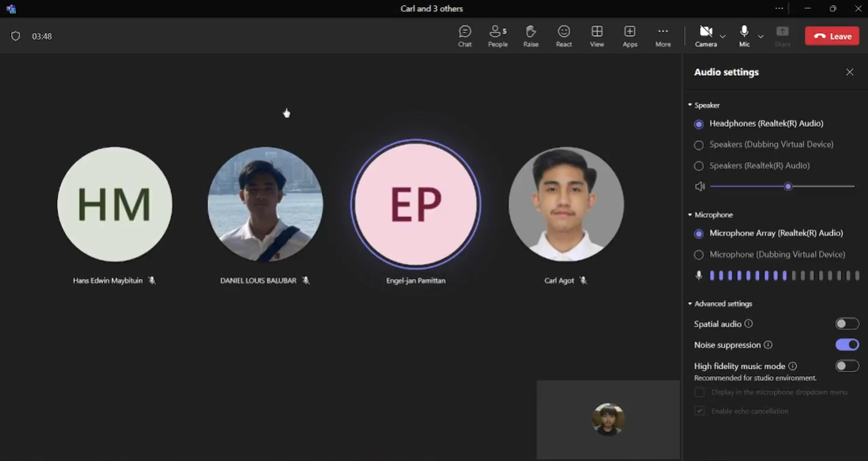

Date: June 24, 2024
Time: 7:00 PM – 8:00 PM
Attendees  - Hans Edwin Y. Maybituin  - Daniel Louis Balubar  - Carl Agot  - Noel Catabona  - Edson Y. Maybituin | Purpose / Objectives  - Final Meeting with the Client.  - Compilation of the Project and the requirements for Presentation.  - Showing the Client the Figma/Framework of our Solution System.
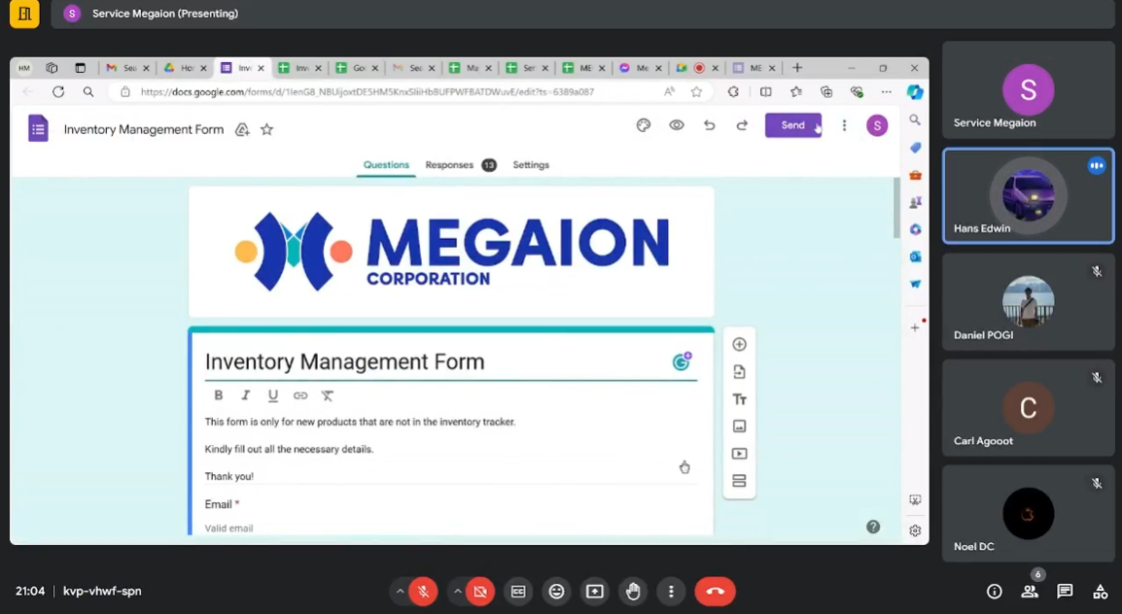

Appendix F: Data Dictionary

Field Name | Data Type | Description | Constraints/Notes
UCF |  | Use Case Fully Diagram | UCF- 01 up to  UCF - 10
Supplier |  | Entity representing suppliers of products
sup_id | Integer (25) | Supplier identification number. | Primary Key
sup_fname | varchar (255) | First name of the supplier contact.
sup_lname | varchar (255) | Last name of the supplier contact.
sup_contact | Integer (25) | Contact number for the supplier.
Customer |  | Entity representing customers who place orders
cus_id | Integer (25) | Customer identification number. | Primary Key
cus_fname | varchar (255) | First name of the customer.
cus_lname | varchar (255) | Last name of the customer.
cus_address | varchar (255) | Address of the customer.
cus_contact | Integer (25) | Contact number for the customer.
cus_email | varchar (255) | Email address of the customer.
Shipment |  | Entity for tracking product shipments
ship_id | Integer (25) | Shipment identification number. | Primary Key
prdct_id | Integer (25) | Identifier for the product being shipped. | Foreign Key from product
po_id | Integer (25) | Identifier for the associated purchase order. | Foreign Key from purchase_order
ship_status | varchar (255) | Status of the shipment (Retrieval, Shipment).
ship_date | date | Date of the shipment.
Inventory |  | Entity for managing inventory details
Invent_Id | Integer (25) | Inventory record identification number. | Primary Key
prdct_id | Integer (25) | Identifier for the product in inventory. | Foreign Key from product
prdct_categ | varchar (255) | Category of the product.
prdtc_desc | varchar (255) | Description of the product.
prdtc_name | varchar (255) | Name of the product.
prdct_quan | Integer (25) | Quantity of the product available in inventory.
Warehouse_Id | Integer (25) | Identifier for the warehouse storing the product. | Foreign Key from Warehouse
AI_chats |  | Entity for storing AI chat interactions
AI_chat_ID | Integer (25) | Unique identifier for each AI chat entry. | Primary Key
AI_chat | varchar (255) | Text of the chat entry.
AI_chat_type | ENUM | Type of chat entry (e.g., "query" or "response").
Product |  | Entity representing products available for sale or inventory
prdtc_id | Integer (25) | Product identification number. | Primary Key
prdtc_categ | varchar (255) | Category of the product.
prdtc_desc | varchar (255) | Description of the product.
prdtc_amt | Integer (25) | Amount available or total count of the product in stock.
prdtc_price | Integer (25) | Price of the product.
prdtc_name | varchar (255) | Name of the product.
AI_chat_history |  | Entity for logging AI chat history
AI_chat_history_ID | INT (10) | Unique identifier for each chat history record. | Primary Key
AI_chat_history_name | VARCHAR (30) | Name associated with the chat history record.
user_id | INT (10) | Identifier for the user associated with the chat entry. | Foreign Key from Users
Staff_roles |  | Entity defining roles of staff members
staff_roleID | Integer (25) | Staff Role identification number. | Primary Key
staff_fname | Integer (25) | First name of the staff member.
staff_lname | varchar (255) | Last name of the staff member.
staff_role | varchar (255) | Role of the staff member (e.g., Manager, Operator).
Purchase_order |  | Entity representing customer purchase orders
po_id | Integer (25) | Purchase order identification number. | Primary Key
po_date | date | Date of the purchase order.
po_time | Integer (25) | Time of the purchase order.
cus_id | Integer (25) | Identifier for the customer placing the order. | Foreign Key from customer
Staff |  | Entity representing staff members involved in operations
staff_id | Integer (25) | Staff identification number. | Primary Key
staff_fname | Integer (25) | First name of the staff member.
staff_lname | varchar (255) | Last name of the staff member.
staff_contact | Integer (25) | Contact number of the staff member.
Warehouse |  | Entity for warehouse locations storing inventory
Warehouse_Id | Integer (25) | Warehouse identification number. | Primary Key
Warehouse_name | varchar (255) | Name of the warehouse.
Warehouse_Loc | varchar (255) | Location or address of the warehouse.

